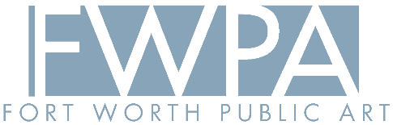

PADDOCK PARK PUBLIC ART PROJECT
CALL FOR CURATORS

SUBMISSION DEADLINE EXTENDED TO MONDAY, JUNE 9TH, 11:59PM

Questions & Responses:

Q: I have connections with many Native artists, but my curatorial experience does not include large-scale projects. Should I still apply?
A: Yes! The curatorial panel will collectively nominate artists to be considered for the Paddock Park Public Art Project. Your experience telling the Native story and connection with artists may be valuable to the group. It is more important for the artists being considered to have experience with large-scale artworks than the curators to have worked on public art projects.

Q: I am a public art administrator, not strictly a curator. Should I still apply?
A: Yes! The curatorial panel will collectively nominate artists to be considered for the Paddock Park Public Art Project. Your experience and connection with artists telling the Native story through public art may be valuable to the group.

Q: What is the time commitment for this project?
A: There are 3-4 meetings anticipated for the curatorial panel. One meeting (≤2 hours) with community representatives and project stakeholders to get site and cultural context; One or two meetings with fellow curators to discuss potential artists and create a final pool of 6-8 artists for consideration; One selection panel meeting (2 hours) where the pool of artists will be presented and narrowed to 3 finalists. All curator work is anticipated to be complete by the end of this summer.

Q: Will meetings take place during normal work hours or be scheduled based on committee member time consensus?
A: The meetings will be scheduled on committee member time consensus. The first meeting and selection panel meetings do often end up occurring during the evening when community members are off work. The curatorial panel meetings will be set by the selected panel members.

Q: Is travel necessary for this role?
A: At this time, all meetings are planned for virtual involvement. If a site meeting is to be conducted, then travel to Fort Worth will be required, and a travel stipend will be provided.

Q: Do I submit my application information to Alida Labbe directly?
A: Yes, email your submission to Alida Labbe at alabbe@artsfortworth.org.

